**On Traffic-Aware Partition and Aggregation in MapReduce for Big Data Applications**

**ABSTRACT**—The MapReduce programming model simplifies large-scale data processing on commodity cluster by exploiting parallel map tasks and reduce tasks. Although many efforts have been made to improve the performance of MapReduce jobs, they ignore the network traffic generated in the shuffle phase, which plays a critical role in performance enhancement. Traditionally, a hash function is used to partition intermediate data among reduce tasks, which, however, is not traffic-efficient because network topology and data size associated with each key are not taken into consideration. In this paper, we study to reduce network traffic cost for a MapReduce job by designing a novel intermediate data partition scheme. Furthermore, we jointly consider the aggregator placement problem, where each aggregator can reduce merged traffic from multiple map tasks. A decomposition-based distributed algorithm is proposed to deal  
with the large-scale optimization problem for big data application and an online algorithm is also designed to adjust data partition and aggregation in a dynamic manner. Finally, extensive simulation results demonstrate that our proposals can significantly reduce network  
traffic cost under both offline and online cases.

**EXISISTING SYSTEM:**

Intermediate data are shuffled according to a hash function in Hadoop, which would lead to large network traffic because it ignores network topology and data size associated with each key. To tackle this problem incurred by the traffic-oblivious partition scheme, we take into account of both task locations and data size associated with each key in this paper. By assigning keys with larger data size to reduce tasks closer to map tasks, network traffic can be significantly  
reduced.

To further reduce network traffic within a MapReduce job, we consider to aggregate data with the same keys before sending them to remote reduce tasks. Although a similar function, called combiner, has been already adopted by Hadoop, it operates immediately after a map task solely for its generated data, failing to exploit the data aggregation opportunities among multiple tasks on different machines.

**Disadvantages:**

* Traditionally, A hash function is used to partition intermediate data among reduce tasks, which, however, is not traffic-efficient because network topology and data size associated with each key are not taken into consideration.
* It leads to large network traffic because it ignores network topology and data size associated with each key.
* Network traffic can be significantly reduced.

**PROPOSED SYSTEM:**

In this paper, we jointly consider data partition and aggregation for a Map Reduce job with an objective that is to minimize the total network traffic. In particular, we propose a distributed algorithm for big data applications by decomposing the original large-scale problem into several sub problems that can be solved in parallel. Moreover, an online algorithm is designed to deal with the data partition and aggregation in a dynamic manner. Finally, extensive simulation results demonstrate that our proposals can significantly reduce network traffic cost in both offline and online cases.

**Advantages:**

* Each aggregator can reduce merged traffic from multiple map tasks. It is designed to adjust data partition and aggregation in a dynamic manner.
* It can significantly reduce network traffic cost in both offline and online cases.

**ARCHITECTURE:**

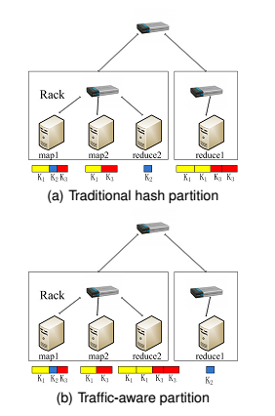

**Fig. 1**. Two MapReduce partition schemes.

**SYSTEM REQUIREMENTS:**

**HARDWARE REQUIREMENTS:**

* System : Pentium IV 2.4 GHz.
* Hard Disk : 40 GB.
* Floppy Drive : 1.44 Mb.
* Monitor : 15 VGA Colour.
* Mouse : Logitech.
* Ram : 512 Mb.

**SOFTWARE REQUIREMENTS:**

* Operating system : Windows XP/7.
* Coding Language : JAVA
* Frontend : AWT, Swings
* Backend : MySQL
* Tools : Cygwin